|  |  |  |  |  |  |  |  |  |
| --- | --- | --- | --- | --- | --- | --- | --- | --- |
|  | **Lp.** | **Leśnictwo** | **Oddział** | **Jezioro** | **Termin rezerwacji** | | | |
|  | **VI 2025** | **VII 2025** | **VIII 2025** | **Maksymalna liczba osób** |
|  | 1 | Witówko | 97 | Warchały |  | 1-25 VII 2025 | wolny | 70 |
|  |  |
|  | wolny |
|  | 2 | Narty | 84 | Krzywek | wolny | 1-29 VII 2025 | wolny | 70 |
|  |
|  |
|  | 3 | Galwica | 260 | Klimek  (Konik) | wolny | 5-30 VII 2025 | wolny | 150 |
|  | 4 | Galwica | 177 | Średnie | wolny | 1-29 VII 2025 | wolny | 80 |
|  |
|  |
|  |
|  |  |  |  |  |  |  | |  |  |  |  |

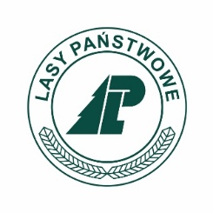

**HARMONOGRAM - OBOZOWISKA HARCERSKIE 2025**